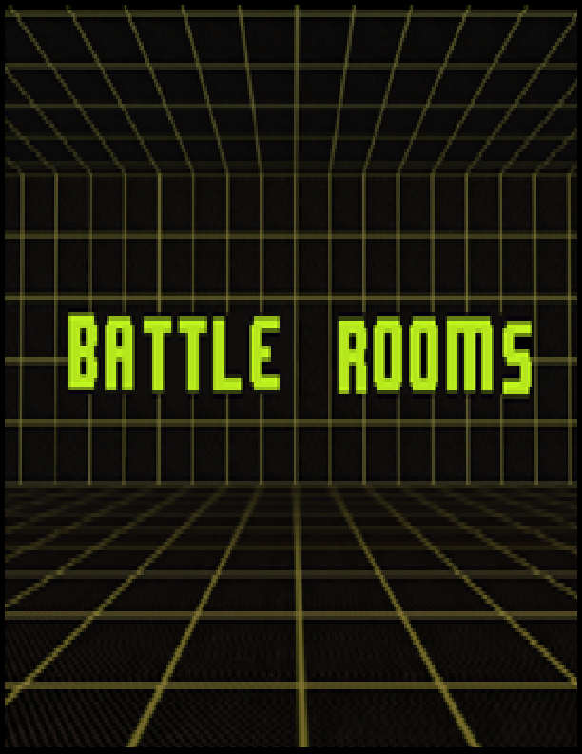

**“Leave your friends behind!”**

**Design Document**

**Rev. 16.0**

**Developers:**

**Katrina Anderson**

**Patrick Modafferi**

**Christopher Di Fulvio**

**Matthew Tam**

**Table of Contents**

List of Figures 4

1 Executive summary 5

2 Overview 5

2.1 Market 5

2.2 Gameplay and Mechanics 5

2.3 Selling Points 6

2.4 Reference Art 6

2.5 Related Games 6

3 Related games 7

3.1 *Fuzion Frenzy* 1-2 7

3.2 *Mario Party* 1-9 8

3.3 Rayman Raving Rabbids 9

3.4 Sonic Shuffle 11

4 Player composites 12

4.1 Primary Market: 12

4.2 Secondary Market: 12

5 World 12

5.1 Setting 12

5.2 Narrative 13

5.3 Back Story 13

6 Characters 13

6.1 Antagonist; Kostaba the Evil Wizard. 13

6.2 Protagonists; The Developers 14

7 Progression graph 16

8 Art direction 17

9 UI storyboards 20

10 Tags and dialogue 23

10.1 Script and Dialogue 23

10.2 Tags 26

11 Technology plan 27

11.1 Programming Technology 27

11.2 Art Asset Technology 27

11.3 Management Technology 28

11.4 Hardware Technology 28

12 Software architecture 29

13 Controls 31

13.1 Main Menu 31

13.2 Lumberjack Bustle 31

13.3 Bumper Balls 31

13.4 Fireball Tactics 31

13.5 Dueling Dunes 31

14 Level design 32

14.1 Battle Room 32

14.2 Instruction Screens 32

14.3 Lumberjack Bustle 33

14.4 Bumper Balls 33

14.5 Fireball Tactics 34

14.6 Dueling Dunes 34

15 Mechanics analysis 35

15.1 Lumberjack Bustle 35

15.2 Bumper Balls 36

15.3 Fireball Tactics 36

15.4 Dueling Dunes 37

15.5 Score 37

16 Schedule & Related Elements 40

16.1 Meeting Minutes 40

16.2 Schedule 44

17 Budget 45

18 Change log 49

Appendix A References 50

Appendix B Credit 51

# List of Figures

Figure 2‑1 Logo [12] 5

Figure 3‑1 Fuzion Frenzy 1 & 2 [1,2] 7

Figure 3‑2 *Mario Party* 9 [12] 8

Figure 3‑3 Raving Rabbids [6,7,8] 9

Figure 3‑4 Sonic Shuffle [9,10] 11

Figure 7‑1 Plot graph for menus 16

Figure 7‑2 Plot Graph for story mode 16

Figure 8‑1 Holodeck 17

Figure 8‑2 Concept Art Bumper Balls 18

Figure 8‑3 Bumper Balls Finished Product 18

Figure 8‑4 Original LB Background 19

Figure 8‑5 Final LB Background 19

Figure 8‑6 Emulogic Font Bitmap 19

Figure 9‑1 Box Art 20

Figure 9‑2 Mock Title Screen 20

Figure 9‑3 Mock Mini game Select Screen 21

Figure 9‑4 Instruction Screen Original 21

Figure 9‑5 Mock Score Screen 22

Figure 12‑1 Mini game Architecture 29

Figure 14‑1 Battle Room 32

Figure 14‑2 Instruction Screens 32

Figure 14‑3 Lumberjack Bustle Game Map 33

Figure 14‑4 Bumper Balls Game Map 33

Figure 14‑5 Fireball Tactics Game Map 34

Figure 14‑6 Dueling Dunes Game Map 34

Figure 15‑1 Lumberjack Bustle Score in Story Mode 37

Figure 15‑2 Bumper Balls Score in Story Mode 38

Figure 15‑3 Fireball Tactics Score in Story Mode 39

Figure 16‑1 Gantt Chart Development Schedule 44

# Executive summary

In Battle Rooms, four friends find themselves trapped by an evil wizard in a magical room. The room has the magic ability to transform completely, transporting players to imaginary places in a flash where they must compete in a series of cruel yet comical mini games. Battle Rooms is of the party game genre and thus will appeal to a wide range of audiences, including recreational gamers and families, looking for a group activity.

# Overview

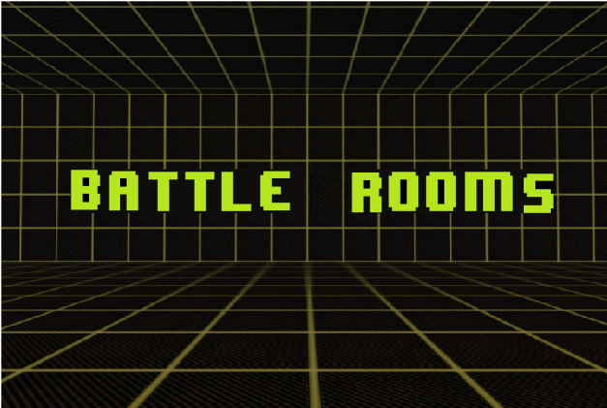

Figure 2‑1 Logo [12]

|  |  |  |  |
| --- | --- | --- | --- |
| **Title** | **BATTLE ROOMS** | | |
| **Tag Line** | **“Leave your friends behind!”** | | |
| **Genre** | Party Game (Mini Game) - Adventure | | |
| **Platforms** | Xbox 360 (2D) | | |
| **Setting** | Magical room that hosts a series of mini games players must win to escape an evil wizard. Science fiction mixed with Fantasy | | |
| **Plays Like** | Mario Party | meets | Wario Ware |

Four friends are trapped by an evil wizard in a magical room. The room has the magic ability to transform completely, transporting players to imaginary places in a flash. The wizard forces them to compete in a series of cruel yet comical mini games. Players who perform well in these games are rewarded. For those who loose, the consequences are dire.

In this document, we will discuss more in depth on the topics listed below along with tags, dialogues, UI progressions and script. Level design and controls for each mini gam will be given. This work will also contain managerial artifact like technology used, change logs, schedule, and budget and meeting times.

## Market

The primary target market for this game is the casual crowd of gamers who enjoy playing with others. A secondary target is families and early teen children. We will elaborate more on player profiles in section 4 of this document.

## Gameplay and Mechanics

## 

The story mode will play out like a gladiator type tournament where only one player survives and is crowned champion of the magical wizard games. These mini games are short survival, precision timing and reflex based games which can be free-for-all, 2vs.2 1vs.1 or 1vs.3 and the teams will be selected based on the current scores. These teams will have to be coordinated in order to progress. Players can also opt to select mini games from a list as opposed to the more competitive story mode.

Please refer to section “15 - Mechanics Analysis” for more details

## Selling Points

What sets this game apart from other mini game based games is the storyline which can be engaging to a general audience. This game can also be appealing due to the level of complexity of each of the mini games. Rather than settling for many simple games, battle rooms consists of fewer games which are complete with environment decor, random factors, balanced gameplay and multiple mechanics per game. Another selling point would be how expandable the game is. The framework, described in more detail in the section 12 - Software Architecture, allows for scalability and maintainability of the source code. Future iterations on the game would be simple since a mini game can simply be coded then pasted in to fit the frameworks parameters.

## Reference Art

The reference art for this game is a light fantasy, older styled game like Final Fantasy for the mini game universe. And a more cartoon science fiction look for the menus in the “real world” universe.

Please refer to section “8 – Art Direction” for more information about art.

## Related Games

Some related games include Fuzion Frenzy, Mario Party franchise and Rayman Raving Rabbids. For more related games and details on these related games refers to section 3 in this document.

# Related games

## *Fuzion Frenzy* 1-2

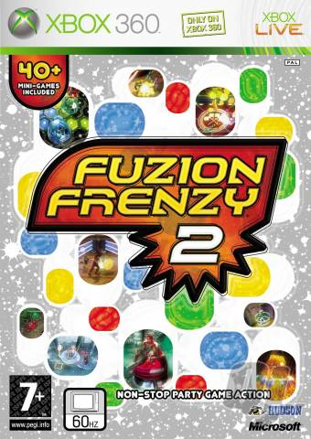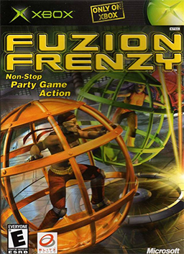

|  |  |
| --- | --- |
| **Author:** | Microsoft Game Studios |
| **Release Date(s):** | *Fuzion Frenzy* – 11/14/2001  *Fuzion Frenzy 2* – 01/30/2007 |
| **Genre:** | Party Game - Adventure |
| **Platforms:** | XBox,  XBox 360 |
| **Market:** | Everyone |

Figure 3‑1 Fuzion Frenzy 1 & 2 [1,2]

### Overview & Design

*Fuzion Frenzy* is Microsoft’s offering to the mini game genre. Both versions *of Fuzion Frenzy* feature up to forty mini games, support up to 4 human players and two game play modes: “Tournament” and “Mini game Frenzy” ”. “Mini game Frenzy” allows for players to choose which of the games they would like to play, while “Tournament” forces players to progress through a randomly generated set of themed zone. Each game zone features a set of three mini games through which players compete in order to obtain orbs. At the end of each zone players compete in a “Fuzion Frenzy” round where they can gain new orbs or steel opponent orbs. Orbs are exchanged for points and the player with the most points at the end of the game wins. In *Fuzion Frenzy 2* orbs were removed from the game in favor of awarding points to players directly after mini games. In addition, *Fuzion Frenzy 2* offered item and card based awards to characters, which could favor the odds for the player using them.[1,2,3]

### Unique Selling Points, Success & Failures

*Fuzion Frenzy’s* main selling features included its colorful visuals and fast-paced mini games, which appealed to all ages and demographics. The mini games where easy to pick up and allowed players to socialize with friends. *Fuzion Frenzy 2* also featured an online play component, eliminating the lack of single player appeal in the original *Fuzion Frenzy* [1,2,3].

While the first installment of *Fuzion Frenzy* was well received, the second fell short winning the title of "Worst Game of the Year" from *Game Informer* magazine. *Fuzion Frenzy 2* was criticized for: Introducing the character DJ Varcanno, a game-show like host who was considered irritating; Introducing the card based item, which placed too much emphasis on luck in the game and lastly the game was considered expensive[1,2,3].

### Influence on Battle Rooms

Battle Rooms, like *Fusion Frenzy*, is also a party genre program composed of mini games that can be played by up to 4 human players. Like Battle Rooms, *Fusion Frenzy* features two game modes: "Tournament" or "Mini game Frenzy" and is aimed at the same demographic, everyone. Unlike its counterparts, *Fuzion Frenzy* does not feature a game board element as part of its tournament mode. Battle Rooms will also progress from one mini game to another without the inclusion of a game board. In addition, Battle Rooms will have a timer associated to its games, much like *Fuzion Frenzy*.

## *Mario Party* 1-9

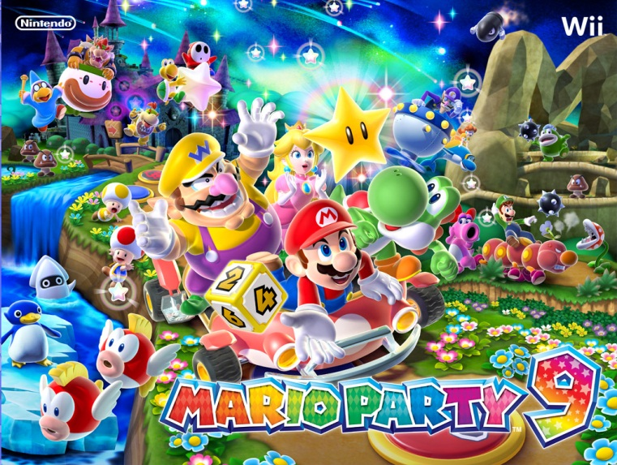

Figure 3‑2 *Mario Party* 9 [12]

|  |  |
| --- | --- |
| **Author:** | Nintendo |
| **Release Date(s):** | *Mario Party* – 12/14/1998  *Mario Party 2* – 12/17/1999  *Mario Party 3* – 12/07/2000  *Mario Party 4* – 10/21/2002  *Mario Party 5* – 11/10/2003  *Mario Party 6* – 11/18/2004  *Mario Party 7* – 11/07/2005  *Mario Party 8* – 05/29/2007  *Mario Party 9* – 03/02/2012 [4,5] |
| **Genre:** | Party Game - Adventure |
| **Platforms:** | Nintendo 64,  GameCube,  Wii |
| **Market:** | Recreational Gamers,  Families |

### Overview & Design

With 9 installments over three gaming platforms, *Mario Party* is the most successful series in the party game genre. All of the *Mario Party* installments feature fifty to ninety mini games and two modes of play, “Party Mode” and “Mini game Mode”. “Mini game Mode” allows for players to choose which mini games they would like to play, while “Party Mode” allows players to progress on a board and play randomly assigned mini games. In “Party Mode” players are awarded coins for their success, with which they can purchase stars. The game ends when players reach the end of the board, the player with the most stars wins. Often the “Party Mode” is fueled by a story in which Bowser, a Nintendo franchise character, is up to some evil scheme and players must race to stop him. Bowser often acts as a wild card in the game, redistributing coins, stars and positions of players on the game board [4,5].

*Mario Party* features many types of mini games: Free-for-all, where players play individually trying to win the game; 2-on-2, where players team up against each other to win games; 1-on-3, where three players team against one, often the leader, to get ahead in the game; Battle, where the prize for winning is other players coins and stars and lastly, duel or 1-on-1, where only two players compete for a chance at their opponents coins and stars [4,5].

### Unique Selling Points, Success & Failures

*Mario Party*’s main selling feature and success has been its appeal to all demographics. It’s cartoonish animation and characters make the game family friendly as does the simplicity of the games. The games are simple to pick-up and luck is as much a factor as skill in this series. In addition, *Mario Party* is a social game, allowing friends and families to have fun with one another without taking the game play too seriously [4,5].

The *Mario Party* series has faced a few setbacks: In the original game, some mini games required the “rotation of the analogue stick,” which often caused players to develop blisters on the palms of their hands. Future installments in the series eliminated this type of game play. In 2007, *Mario Party* 8 had to be pulled off the shelves in the UK, due to the use of the term “spastic,” which is considered offensive. The term was replaced by the word “erratic” and the game was re-released [4,5].

### Influence on Battle Rooms

Battle Rooms, like *Mario Party*, is a mini game based console game. Similar to *Mario Party*, Battle Rooms’ mini games can feature up to four human players and can be a free-for-all, 2 vs. 2, 3 vs. 1 or duel. In addition, Battle Room has two game play types: “Story” and “Mini Games”, much like *Mario Party’s* “Party Mode” and “Mini game Mode.” Battle Rooms will be aimed at the same demographic as *Mario Party*; Social situations for people of all ages who wish to enjoy a light gaming atmosphere. The design for Battle Rooms mini games will be influenced by the mini game dynamics of *Mario Party*. Namely they will have short durations and use few controls so as to facilitate game comprehension.

## Rayman Raving Rabbids

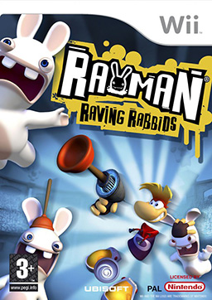

|  |  |
| --- | --- |
| **Author:** | Ubisoft |
| **Release Date(s):** | *Rayman Raving Rabbids* – 11/14/2006 |
| **Genre:** | Party Game - Adventure |
| **Platforms:** | Game Boy Advance,  Wii,  PlayStation 2,  Nintendo DS,  Microsoft Windows,  Xbox 360 |
| **Market:** | Everyone |

Figure 3‑3 Raving Rabbids [6,7,8]

### Overview & Design

*Rayman Raving Rabbids*, created by Ubisoft for a variety of platforms the primary being the Wii, is the first installment in the *Rabbids Series*, which is made primarily of party genre games. The Game is comprised of two modes, the first “Story Mode” supports only one player, Rayman, who is kidnapped by the Rabbids and forced to participate in a fifteen day mini game tournament before his eventual escape. Each tournament is comprised of four trials, the last of which is a “Boss” type trial. If Rayman wins the trials he is awarded a plunger. Rayman needs fifteen plungers in order to fashion a ladder for his escape. *Rayman Raving Rabbids* also features a “Score Mode” where friends can compete in the trials together or perfect their scores [6,7,8].

*Rayman Raving Rabbids* features four mini game types: “Bunny Hunt”, or the boss type mini games, which is often a first person rail shooter; “Sports & Challenges” which requires rapid or precise movements of the Wii remote and “Shake your Booty!” dance challenges [6,7,8].

### Unique Selling Points, Success & Failures

*Rayman Raving Rabbids* selling points and successes where primarily to do its humorous story line, music, sound and addictive fast-paced gameplay. *Rayman Raving Rabbids* appealed to a wide demographic because of its ease of use and family friendly game play [6,7,8].

*Rayman Raving Rabbids* fell short on platforms other than the Wii, where gameplay was not optimized and did not offer the same addictive experience. In addition, not all mini games where well thought out or bug free. Lastly, some of the mini games in *Rayman Raving Rabbids* where criticized for not being multiplayer capable [6,7,8].

### Influence on Battle Rooms

*Rayman Raving Rabbids* is a party game where up to four players play in two different modes. The more important to Battle Rooms of these two is the 'Score mode'. This mode allows the players to get points for each mini game that they play. The player with the most points at the end of a set number of mini games is declared the winner. Battle Rooms, will also attempt to mimic the style of humor offered in *Rayman Raving Rabbids,* which is described as somewhat sadistic [6,7,8].

## Sonic Shuffle

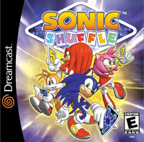

Figure 3‑4 Sonic Shuffle [9,10]

|  |  |
| --- | --- |
| **Author:** | Sega |
| **Release Date(s):** | *Sonic Shuffle* – 11/13/2000 |
| **Genre:** | Party Game - Adventure |
| **Platforms:** | Dreamcast |
| **Market:** | Everyone |

### Overview & Design

*Sonic Shuffle*, which was released by Sega for the Dreamcast, is a party genre game that supports single player as well as multiplayer gaming. The game features a “Story Mode” through which a single player goes out on an adventure, composed of a series of mini games, to save “Maginary World” from a villain named Void. The other player modes “Versus Mode” and “Sonic Room” allow for up to four human players to play together. *Sonic Shuffle* features about fifty mini games and five game boards on which players can play. Players progress through the game boards by playing mini games and winning emblems, the player who reaches the end of the game board with the most emblems wins the game board. Players progress through the game board by picking up cards that dictate the number of spaces they must move or act as wild cards, providing bonuses and taking away emblems. The game board also features wild spaces adding more elements of chance to the gameplay. Sonic Shuffle’s mini games features team play (2 vs. 2, 1 vs. 3) as well as free-for-all games [9,10].

### Unique Selling Points, Success & Failures

*Sonic Shuffle’s* main selling point was its inclusion of characters from its highly popular Sonic the Hedgehog Franchise. The game was not well received and was criticized for trying to copy the highly popular series *Mario Party.* Players were also unhappy with the games story line, which was lengthy, taking away from the fast paced and social nature of the party game genre [9,10].

### Influence on Battle Rooms

Battle Rooms, like *Sonic Shuffle’s* “Versus Mode” and “Sonic Room” will allow players to compete in a story context, where mini games are randomly chosen, or at will, where players can choose their favorite mini games to play. Similar to *Sonic Shuffle*, Battle Rooms’ mini games can support up to four human players and can be a free-for-all, 2 vs. 2 or 3 vs. 1. Battle Rooms will attempt to learn from the mistakes made in Sonic Shuffle, meaning that the focus will be put on the mini games as oppose to the story.

# Player composites

## Primary Market:

### Casual Gamers Profile

TJ Newbie is a 17-year-old student who just graduated high school. He lives with his parents who grant him a generous allowance of $5 per week. He is outgoing with many friends. He likes to play competitive games with his friends on the weekends, like Super Smash Bros Brawl and NHL 13. He owns an iPhone 4 where he likes to play Angry Birds, Bejeweled and The Simpsons Tapped Out when he is on the bus. He prefers games that don’t take up a lot of time and that he can play with groups of people. He is also a soccer fan, and plays on his team three nights a week. When he is not playing games, studying or playing soccer, he likes to watch Criminal Minds and Bones on TV.

## Secondary Market:

### Children Gamer Profile

Emma Von Vlunjgervoot is a 10-year-old girl who is in primary school. She is a very social girl who likes to make friends. She likes to play outside and paint. Her favorite uncle usually gives her video games for the holidays and her birthday, like Club Penguin and Super Mario for her Nintendo DS. She also likes to play board games with her family. She isn’t allowed to play games until she has finished all her homework. On the weekends, she likes to watch morning TV on the Disney Channel like iCarly and Hannah Montana. She also listens to the sounds of Justin Bieber and One Direction on her iPod Touch.

### Family Gamers Profile

Michael is a family man. He has a wife and two kids. He is a history professor who works many hours in one week. His wife is a bank teller, and his two kids are both students in middle school. They all have different interests and schedules, so Michael has set aside one day a week where they do activities together as a family. They like to play board games like Monopoly and The Game of Life. They also tend to play games on their Wii together, like Mario Kart and Wii Sports. Sometimes they will go to a movie in theatres together, usually choosing action movies like those from Marvel. When possible, Michael likes to invite his sister and her family over, so that all of the cousins, aunts and uncles can bond and spend time together, often playing sports like touch football or ball hockey.

# World

## Setting

|  |  |
| --- | --- |
| Era | Sometime in the mid-near future. |
| Theme | Fantasy mixed with science fiction. |
| Tone | Light, family friendly and slight humor. |

## Narrative

The Evil Wizard plays video games in his spare time. He gets bored of playing the same old games on TV wants a more fully immersive experience. He seeks out the developers and makes them play in the mini games they created. The winner receives one wish from the wizard.

Please refer to section “6 – Characters“ for back story on the characters in the world

## **Back Story**

Please refer to section “10 – Script and Dialogue” introduction part for motivations and premise for gameplay

# Characters

## Antagonist; Kostaba the Evil Wizard.

|  |  |  |
| --- | --- | --- |
| [11] | **Motivation:** | To be entertained by creating a real life version of his favourite game Battle Rooms, with the developers of the game featured as the contestants. General evilness. |
| **Physical Description:** | Kostaba has a long white beard a magical staff and an endless supply of green robes. Some people say he reminds them of Gandalf the wizard from Lord of the rings, only evil. |
| **Likes and Dislikes:** | Kostaba likes to be evil and enjoys hobbies like fishing, baseball and most of all gaming. Kostaba dislikes being bored with video games. |
| **Family & Friends:** | Kostaba has no friends and family. They all died in a car accident created by another evil wizard. Kostaba grew up and defeated this evil wizard only to become evil himself. |
| **Enemies:** | The evil wizard who killed his family and unicorns. | |
| **Education:** | He graduated from Hogwarts School of Witchcraft and Wizardry. (Yeah he belonged to Slytherin). | |
| **Occupation:** | Evil Wizard | |
| **Transportation:** | Kostaba teleports from one location to another. He never walks. | |
| **Tools/ Weapons:** | A magic staff made of wood. | |
| **Clothing:** | Green robe with matching hat. | |

## Protagonists; The Developers

### Chris

|  |  |  |
| --- | --- | --- |
|  | **Motivation:** | Chris’s primary motivation is to survive Kostaba’s Battle Room by defeating his friends and fellow developers. |
| **Physical Description:** | Chris has dark brown hair, although you can’t see it behind his distinctive blue armour. |
| **Likes and Dislikes:** | Chris likes to play video games and develop video games. His main weakness is asparagus, which he dislikes. | |
| **Family & Friends:** | Chris has a brother and two parents. | |
| **Enemies:** | Kostaba the Evil Wizard | |
| **Frenemies:** | The Developers (Outside the Battle Room they are the best of friends, but only one can survive) | |
| **Education:** | Bachelor in Software Engineering from Concordia University. | |
| **Occupation:** | Game Developer | |
| **Transportation:** | Chris generally gets around by walking, running, ducking, jumping and getting kidnapped by the evil wizard Kostaba. | |
| **Tools/ Weapons:** | A sword made of unbreakable ice, salvaged from an iceberg. | |
| **Clothing:** | Armour from the ice dragon of Iceland. | |

### Katrina

|  |  |  |
| --- | --- | --- |
|  | **Motivation:** | Katrina’s primary motivation is to survive Kostaba’s Battle Room by defeating her friends and fellow developers. |
| **Physical Description:** | Katrina is the only female member of the developers’ team. She is distinguished by her bright pink armour. |
| **Likes and Dislikes:** | Katrina likes to socialise with friends and family and watch endless amounts of television. Katrina doesn’t like the show Lost. | |
| **Family & Friends:** | Katrina has a brother and two parents. | |
| **Enemies:** | Kostaba the Evil Wizard | |
| **Frenemies:** | The Developers (Outside the Battle Room they are the best of friends, but only one can survive) | |
| **Education:** | Bachelor in Software Engineering from Concordia University. | |
| **Occupation:** | Game Developer | |
| **Transportation:** | Katrina generally gets around by walking, running, ducking, jumping and getting kidnapped by the evil wizard Kostaba. | |
| **Tools/ Weapons:** | A sword made from the horn of a unicorn. | |
| **Clothing:** | Armour made from hardened bubble gum. | |

### Matt

|  |  |  |
| --- | --- | --- |
|  | **Motivation:** | Matt’s primary motivation is to survive Kostaba’s Battle Room by defeating his friends and fellow developers. |
| **Physical Description:** | Matt can be identified by his sharp black armour. |
| **Likes and Dislikes:** | Matt likes to play Mahjong and other board games. Matt dislikes when he loses all his money to his aunt while playing Mahjong. | |
| **Family & Friends:** | Matt has a brother, two parents and an aunt. | |
| **Enemies:** | Kostaba the Evil Wizard | |
| **Frenemies:** | The Developers (Outside the Battle Room they are the best of friends, but only one can survive) | |
| **Education:** | Bachelor in Software Engineering from Concordia University. | |
| **Occupation:** | Game Developer | |
| **Transportation:** | Matt generally gets around by walking, running, ducking, jumping and getting kidnapped by the evil wizard Kostaba. | |
| **Tools/ Weapons:** | A sword made of black diamond. | |
| **Clothing:** | Armour made from black sand and ash. | |

### Pat

|  |  |  |
| --- | --- | --- |
|  | **Motivation:** | Pat’s primary motivation is to survive Kostaba’s Battle Room by defeating his friends and fellow developers. |
| **Physical Description:** | Pat can be identified by his luscious green armour, which was inspired from his favourite power ranger. |
| **Likes and Dislikes:** | Pat likes to play sports including hockey and soccer and can’t drink milk. | |
| **Family & Friends:** | Pat has two brothers and two parents. | |
| **Enemies:** | Kostaba the Evil Wizard | |
| **Frenemies:** | The Developers (Outside the Battle Room they are the best of friends, but only one can survive) | |
| **Education:** | Bachelor in Software Engineering from Concordia University. | |
| **Occupation:** | Game Developer | |
| **Transportation:** | Pat generally gets around by walking, running, ducking, jumping and getting kidnapped by the evil wizard Kostaba. | |
| **Tools/ Weapons:** | A sword made of emeralds and chlorophyll. | |
| **Clothing:** | Armour made from finely ground green tea and white glue. | |

# Progression graph

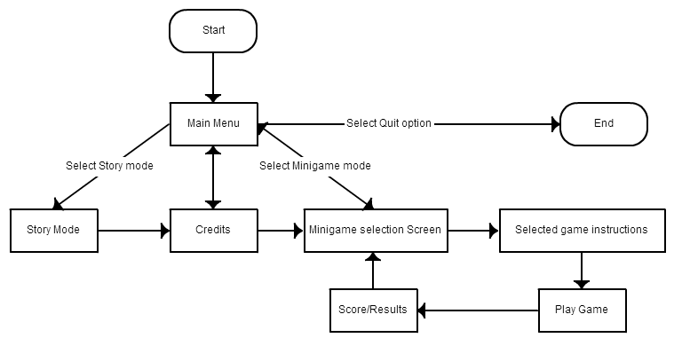

Figure 7‑1 Plot graph for menus

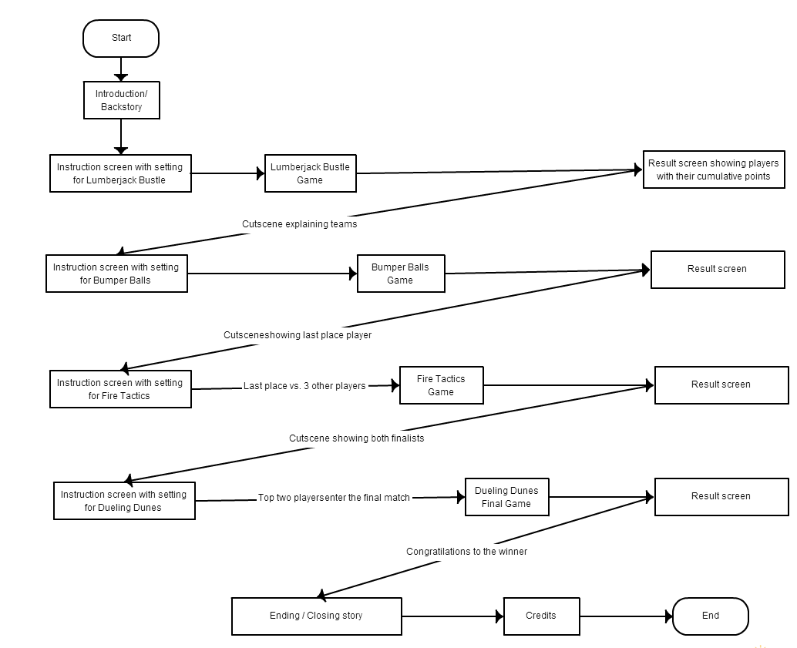

Figure 7‑2 Plot Graph for story mode

# Art direction

When coming up with the graphic style of Battle Rooms, the team decided that it would look 8-bit. The team was inspired by art from games such as Final Fantasy and other similar 8-bit games. Here is some concept art that was created for the game during the proposal phase and inception of the idea:

[12]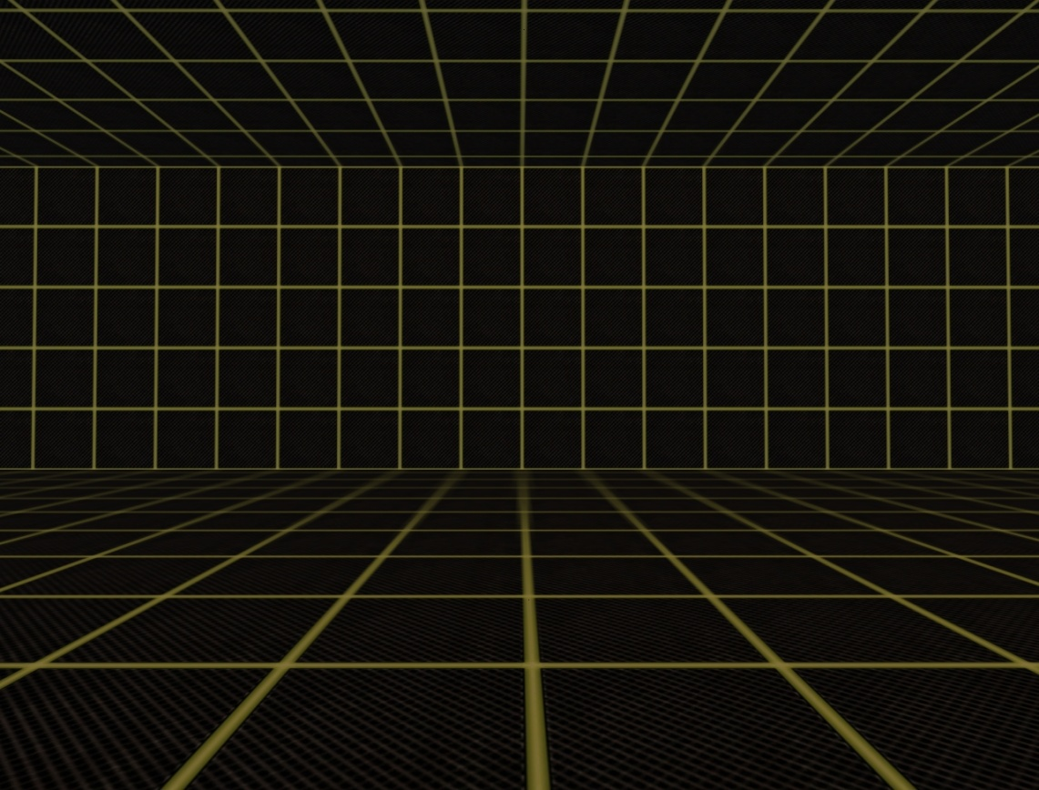

Figure 8‑1 Holodeck

This is a picture of the holodeck, which was one of the main inspirations on the setting of our game, which is where the wizard changes the way the room looks by using magic. This gives a theme to each of the mini games.

For each of the mini games, we decided if each game had a specific element which it represented, then each mini game on their own would have its own unique art direction. For each of our mini games, one can see the difference in the elements:

Lumberjack Bustle shows forests, logs, and spikes

Bumper Balls has a lot of ice and water

Fireball Tactics is in a cave with a lot of fire and fireballs

Dueling Dunes is in an earthy environment, with a swirling vortex of sand

By issuing these elements to the different mini games, players can have a sense of what to avoid, or what is going to happen when you collide with something, for example.

Using the holodeck example of how the rooms change, we created some concept art:

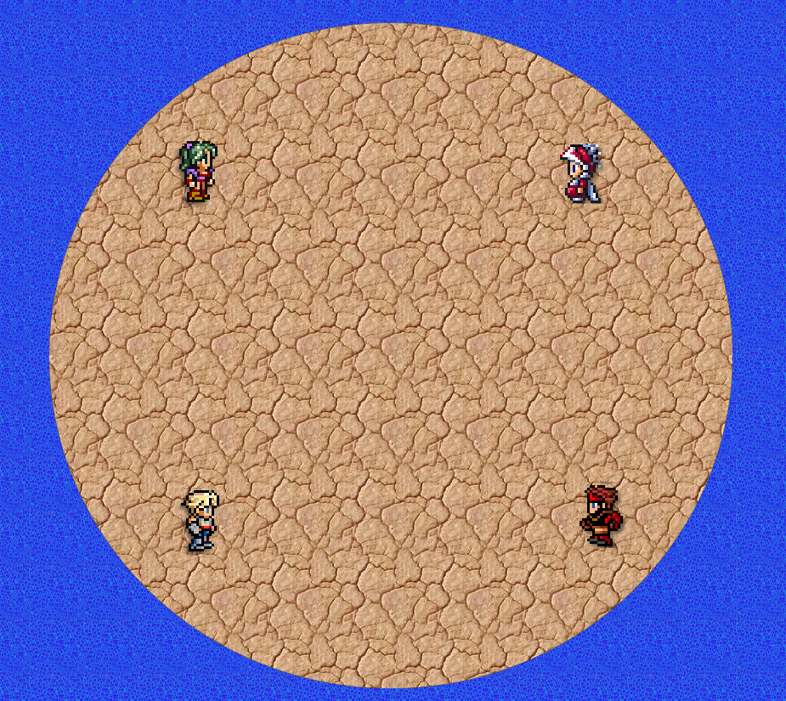

Figure 8‑2 Concept Art Bumper Balls

This was one of the original concept arts for the mini game Bumper Balls. Since we went with an 8-bit style, we used some Final Fantasy characters to show the style, as well as some textures which reflect the same choices. The game as it is completed looks almost the same, only with the characters changed to reflect the characters we chose for the story, and also with a twist with ice as the platform to give the players a feel of what should happen when they bump into each other (low friction).

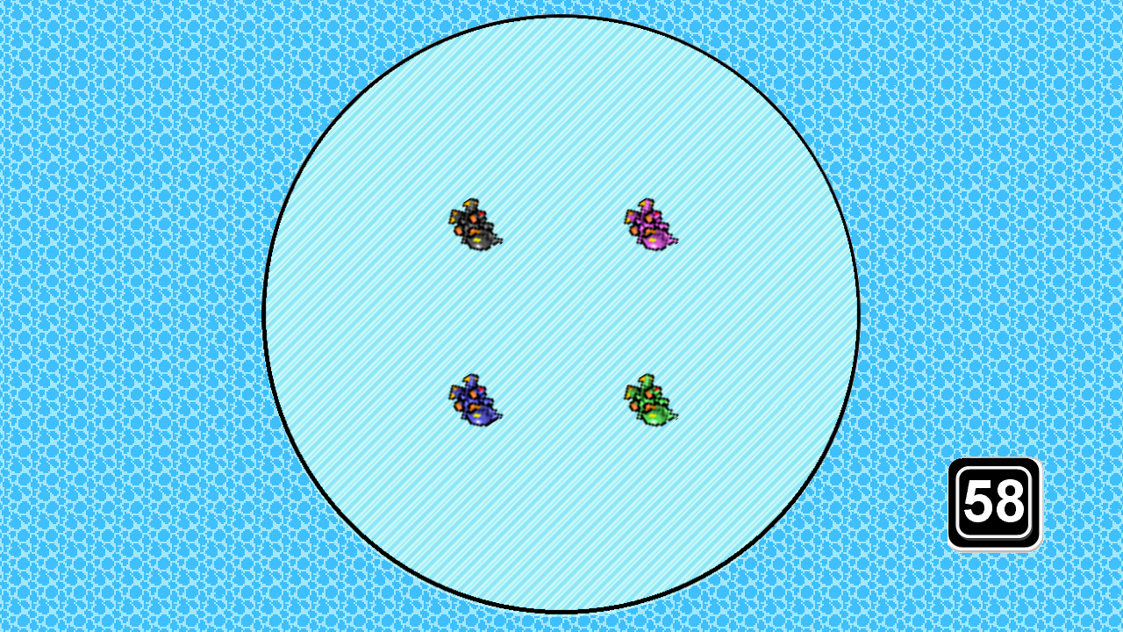

Figure 8‑3 Bumper Balls Finished Product

For one of the other mini games, Lumberjack Bustle, there was a lot of debate on which background we should end up using for the trees. The original art that we were using was a non-8-bit style forest that we eventually ended up removing because it did not fit well with the rest of the style of art that was being used.

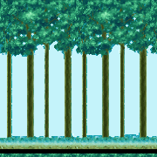

Figure 8‑4 Original LB Background

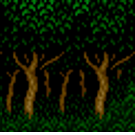

Figure 8‑5 Final LB Background

Staying true to the 8-bit style of the game, a great font was found called emulogic, which has the following bitmap:

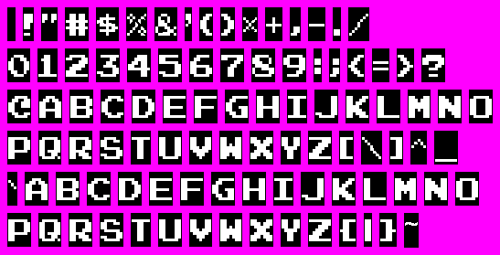

Figure 8‑6 Emulogic Font Bitmap

# UI storyboards

The UI was built around the original box art created for the game:

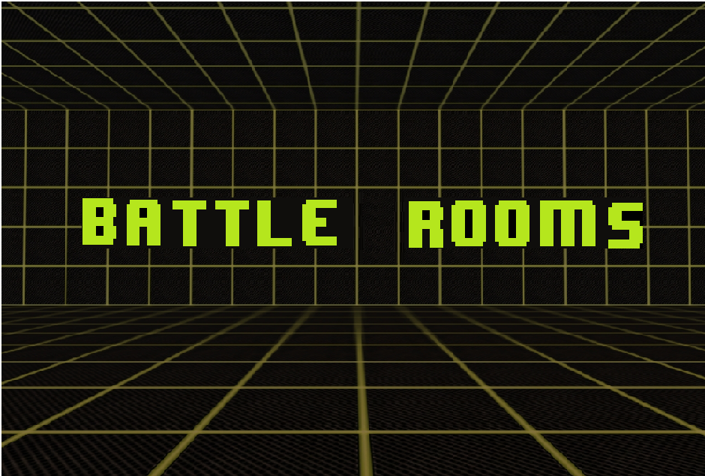

Figure 9‑1 Box Art

From this, the UI elements were storyboarded for how showing the Story, Mini games and Credits would look like, putting in the Emulogic font for story boarding:

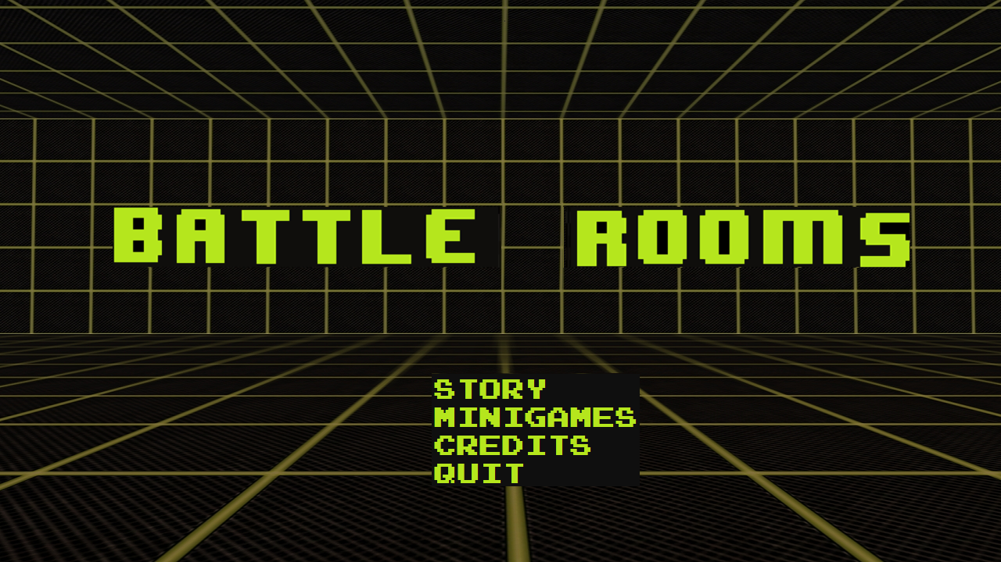

Figure 9‑2 Mock Title Screen

When selecting the story, the player would simply just be shown the same screen with some story written on it so that they may read the story.

When selecting the Mini Games option, the player would be sent to a screen where they would be able to see the list of all mini games and a screenshot of what they would look like:

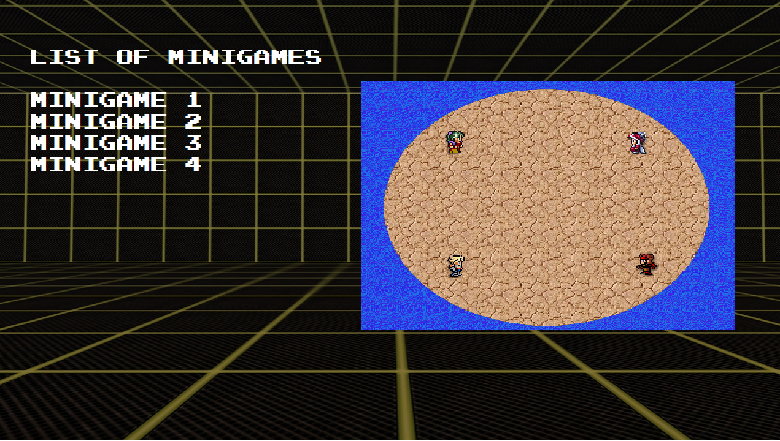

Figure 9‑3 Mock Mini game Select Screen

For the credits, the same background is used but with credits rolling from in game text or a picture.

When a mini game is selected or automatically played via the story mode, the players are entered into an instructions screen where they are told the setting, the objective, and the controls needed to play the game.

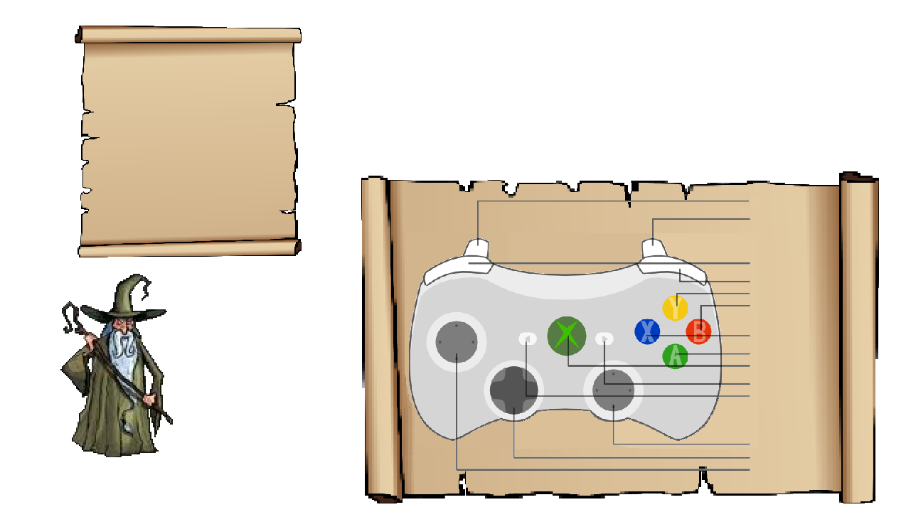

Figure 9‑4 Instruction Screen Original

Shown above is the basic instruction screen with the wizard at the bottom. On the left side is where the description of the mini game goes, with the right side detailing the controls needed to play the game. When the players skip this screen by saying that they are ready, the mini game begins until someone wins or everyone loses. Once this happens, the game enters the scoring screen where the players are shown how many points were obtained from the mini game based on their performance:

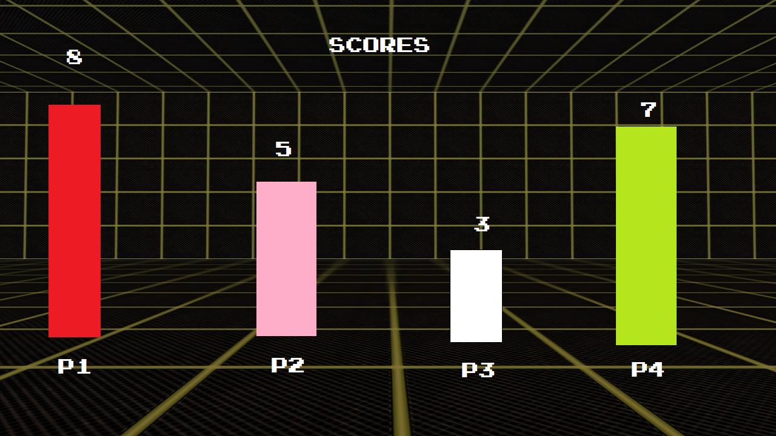

Figure 9‑5 Mock Score Screen

For a state machine showing how the GUI functions, please refer to Figure 7-1 and 7-2.

# Tags and dialogue

## Script and Dialogue

**INT. DARK ROOM – WIZARD’S HOUSE**

Background: A “holodeck” looking room, with the main menu music playing.

NARRATOR:

An evil wizard named Kostaba once lived in a faraway place. Despite being evil, he was a regular person when it came to hobbies. He enjoyed fishing, baseball but most of all gaming. His favorite game was Battle Rooms, a multiplayer party game (yes like Mario Party) created by 4 young developers. One day, Kostaba grew weary of the same old games.

[Press A to continue]

So Kostaba did what any rational evil wizard would do; he kidnapped the game developers and trapped them in a room. After the wizard demanded them to create for him a new Battle Rooms game, the lead developer explained that this could not be done since the copyrights belonged to Apple.

[Press A to continue]

A new idea arose, the wizard could recreate the game using his spectacular magic powers while the developers would compete for the championship. The prize for victory would be a single wish granted by the wizard…

[Press A to continue]

**EXT. FOREST – NIGHT – INSTRUCTION SCREEN**

Background: A forest with a bright moon, where the wizard stands. The Mario Party instruction music plays. A parchment to the left of the screen displays the following instructions:

Description Lumberjack *

[Press A to continue]

**EXT. FOREST – NIGHT – LUMBERJACK BUSTLE MINI GAME**

Background: A thick forest with a vortex spinning behind each player. The Benny Hill theme music plays.

**SCORE SCREEN**

Background: The “holodeck” looking room, with rising colored bars that represent the score of each player. The “Mario Party” instruction music plays.

[Press A to continue]

WIZARD:

Your next test will be a team game. Let’s balance out the teams by matching 1st place with last place.

[Press A to continue]

**EXT. UNICORN FOUNTAIN – DAY – INSTRUCTION SCREEN**

Background: A sparkly unicorn is the background, while the wizard stands before the players. The “Mario Party” instruction music plays. A parchment to the left of the screen displays the instructions:

Description BB*

[Press A to Continue]

**EXT. FROZEN ICECAP – DAY – BUMPER BALLS MINI GAME**

Background: An icecap surrounded by water that is slowly melting. The “Benny Hill” music plays.

**SCORE SCREEN**

Background: The “holodeck” looking room, with rising colored bars that represent the score of each player. The “Mario Party” instruction music plays.

[Press A to continue]

WIZARD:

PLAYER X (Last place player) seems to be doing poorly. However! This can still be anybody’s game. Our lucky loser has a chance to redeem themselves with a win on this 1 vs. 3 type game.

**INT. VOLCANO – DAY – INSTRUCTION SCREEN**

Background: The evil wizard stands in front of a fiery volcano that looks to be ready to erupt. The “Mario Party” instruction music plays. A parchment to the left of the screen displays the following instructions:

Description FT*

[Press A to continue]

**INT. VOLCANO – DAY – BUMPER BALLS MINI GAME**

Background: The interior of the volcano is split into two levels, with the lowest scoring player on the top level and the remaining three players on the bottom. There are two roaring fires on either end of the screen where the three players are running.

**SCORE SCREEN**

Background: The “holodeck” looking room, with rising colored bars that represent the score of each player. The “Mario Party” instruction music plays.

[Press A to continue]

WIZARD:

Ladies and gentlemen, our two finalists await their final test. Who will be the last one standing…

[Press A to continue]

**EXT. DRY DESERT – DAY – INSTRUCTION SCREEN**

Background: The evil wizard stands in the middle of huge sand dunes. The “Mario Party” instruction music plays. A parchment to the left of the screen displays the following instructions:

Description Duel*

[Press A to continue]

**EXT. SWIRLING SAND PIT – DAY – DUELING DUNES MINI GAME**

Background: A swirling sand pit pulls the two dueling players towards the middle. The “Benny Hill” theme music plays.

**SCORE SCREEN**

Background: The “holodeck” looking room, with rising colored bars that represent the score of each player. The “Mario Party” instruction music plays.

[Press A to continue]

**INT. DARK ROOM – WIZARD’S HOUSE – CLOSING SCENE**

WIZARD:

Congratulations PLAYER X (player who wins Dueling Dunes)! You have won, what is your wish?

[Press A to continue]

NARRATOR:

Even though these games were fun, the hero wished to return home with the rest of the team. They all missed their families and their day jobs as game developers. After crying for 6 hours, the wizard finally fulfilled his promise and granted the wish. He would have to wait for Battle Rooms 2 like everyone else.

[Press A to Continue]

Credits Roll

*Represents a Tag Name. See table in next section for the actual values.

## Tags

A string localization system is used to keep track of these tags in the code. The following is the table called Strings.resx which can be used to access each of the tag values from anywhere in the code.

|  |  |
| --- | --- |
| Tage Name | Tag Value |
| AButtonDuel | Run |
| AButtonFT | Jump / Shoot |
| AButtonLumberjack | Jump |
| BButtonDuel | Run |
| BButtonFT | Special Attack |
| ChooseMode | Mini games |
| Credits | Credits |
| CurrentLocale | Current culture: {0} |
| DescriptionBB | Stranded on a melting iceberg and forced to spin uncontrollably, you must survive this wizard`s test. Bump your so called friends off the island to be the last player standing. Work as a team to win.  Press "A" to start. |
| DescriptionDuel | The final test is for the two best. Fight the pull of the sinking sands by pushing the designated button repeatedly. Watch your opponent sink into the abyss, making you the ultimate champion!  Press "A" to start. |
| DescriptionFT | One will throw fire, while the others flee in this wizard's test. Setting three ablaze will allow for one to be the best.  Press "A" to start. |
| DescriptionLumberjack | Race through the wizard's dark forest and secure your place in the living. Careful, the wizard has placed traps you must duck under, jump over or chop through or be slowed down.  Press "A" to start. |
| DirectionalPadBB | Move |
| DirectionalPadFT | Move |
| DirectionalPadLumberjack | Slide |
| ExitGame | Exit Game |
| LeftStickFT | Move |
| PressAContinue | Press "A" to continue |
| ScoreTitle | Scores |
| StoryMode | Story Mode |
| TitleBB | Bumper Balls |
| TitleDuel | Dueling Dunes |
| TitleFT | Fireball Tactics |
| TitleLumberjack | Lumberjack Bustle |
| XButtonDuel | Run |
| XButtonFT | Duck |
| XButtonLumberjack | Slash |
| YButtonDuel | Run |

Note: Any other tags found in the gam are N/A by default

# Technology plan

The technology used in the project can be split into four categories: programming technology, art asset technology, management technology and hardware technology.

## Programming Technology

### Microsoft Visual Studio 2010

The programming IDE used to develop Battle Rooms is Microsoft Visual Studio 2010. The reason why we used this is because XNA Game Studio works in this version (as opposed to Visual Studio 2012, which does not). It is also the only type of IDE that works with XNA Game Studio.

### XNA Game Studio

A requirement for the project was to develop it using this framework. The XNA Game Studio gives game developers a very robust framework that handles all of the backend game manipulation, as well as giving many containers and math related functions typically used in game development.

### Assembla

Assembla was used as the main site for the source code repository. Assembla allows the creation of free Git repositories up to 1GB of data space. Since the team wanted to use Git for source control, as well as knowing that we would not exceed 1GB of space, Assembla was a perfect choice.

Other options for source code repository could have been GitHub or BitBucket. Assembla was chosen over these two because GitHub and BitBucket do not allow you to make private repositories for free.

### Git

Git was the source control used for the project. Other options for source code revision could have been SVN or Mercurial. We chose Git as some people in the team did not know how to use it (since most have been using SVN) and wanted to learn the use of new technologies.

## Art Asset Technology

### GIMP

GIMP is a free to use application very similar to PhotoShop which allows the creation and editing of images that supports layering. It was mainly used for extensive pixel measuring of textures and positioning of backgrounds.

### Paint

Paint, the default image editor that comes packaged with Windows, was used for most trivial tasks that did not require the exact precision that GIMP gives the developer.

### Websites

For art assets, a major component was finding sources over the internet that we could source or credit the creators. Most of the art was obtained from the internet, with a little bit of tweaking using Paint or GIMP to crop out parts of the textures that were not needed.

## Management Technology

### Microsoft Word

Word was used for all documentation. It is an invaluable tool that allows developers to quickly write documents without having to worry too much about indentation, coloring, making a table of contents or even the image list.

### Microsoft Excel

Excel was used mainly for tracking time spent working on different tasks. Team members would log hours that they spent on a specific task, write a small description and put the date.

### Microsoft Visio

Microsoft Visio was used for all architecture diagrams, as well as the Gantt chart explaining our work and how we progressed throughout the project.

### Creately

Creately is a website that has functionality similar to Microsoft Visio, only you are able to share drawings online with other people. The tool generates drawings such as flow charts, class diagrams and use case diagrams directly on a web browser, so any device with an internet connection and browser can access the drawings.

## Hardware Technology

### Xbox360

The main development platform and purpose of the project: to deploy a functional game onto an Xbox 360. Occasionally while testing the game on the PC, the developers would deploy the game on the Xbox 360 so that we can see if the classes and libraries we used were compatible, as well as if the textures and sounds were okay.

### PC

Main hardware used to develop the game, as well as test the game. It housed all of the previous applications that were using in the development of the game.

# Software architecture



Figure 12‑1 Mini game Architecture

Above is the architecture of Battle Room, showing only the architecture of one of the mini games (Lumberjack Bustle). The Game1 class is the main class which decides which mini game or menu to update and draw. The methods are then delegated based on which state the game or menu is in.

When choosing a mini game to play, the MiniGameFactory creates a mini game for Game1. This mini game is then initialized and its content is loaded. The GameState then changes to Mini game, which tells Game1 to delegate its Update and Draw methods to the mini game. This is essentially a small Game1 class dedicated to initializing, updating and drawing the specific mini game that is currently being played.

There are three main components to a mini game, this includes the Instruction class, Character class and PlayerManager class. The Instruction class is the screen which players see before the game begins. It shows the description and controls of the game. The Character class determines what Characters do depending on the type of game that they are playing (in this mini game, the character needs special effects such as a KnockBackEffect). Lastly, the PlayerManager class controls all player input, determines the winners and losers, and does any other special checks that are needed for the specific mini game (in this mini game, it would be the collision between players and the obstacles).

Finally, when navigating the menus, the Menus class determines which menu to show based on the input that the player gives while in each of the menu screens and tells Game1 what the decisions were.

# Controls

See Figure 14-2 Instruction Screens for a graphical representation of game controls.

## Main Menu

Directional Pad – Move selection

A Button – Select

B Button – Cancel/Go Back

## Lumberjack Bustle

Down Directional Pad – Slide

A Button – Jump

X Button – Slash

## Bumper Balls

Directional Pad – Move player

## Fireball Tactics

### Player on Top

Left Directional Pad – Move player left

Right Directional Pad – Move player right

A Button – Shoot fireball

X Button – Special Attack

### Player on Bottom

Left Directional Pad – Move player left

Right Directional Pad – Move player right

A Button – Shoot fireball

X Button – Duck

## Dueling Dunes

A Button – Displayed Command

B Button – Displayed Command

X Button – Displayed Command

Y Button – Displayed Command

# Level design

Battle Rooms is segmented by a series of mini games, which act as levels in the game. Each mini game has its own game maps with distinctive features. None of the mini games in Battle Rooms feature focus nodes, as the only resource the players are attempting to gather are points, which are given after succeeding in a mini game.

## Battle Room

The battle room acts as a choke point between mini games. It’s the location of the main menu and it appears at the end of each mini game to indicate the score. When players play in “Story” mode, the battle room also serves as the backdrop to indicate game progression and to tell the story.

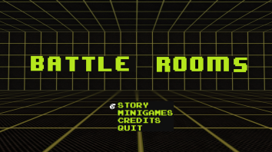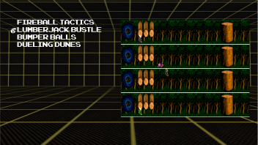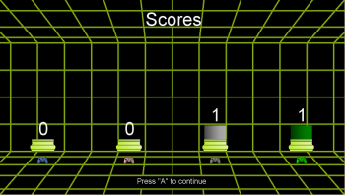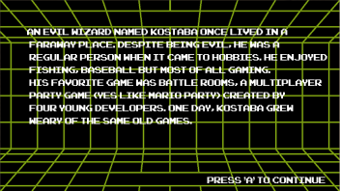

Figure 14‑1 Battle Room

## Instruction Screens

Instruction screens appear before every mini game and, like the battle room, act as a choke point. Before progressing to the next mini game, all players must confirm their attendance and understanding of the game by pressing “A” on their game controllers. Each instruction screen features a backdrop that accompanies the theme of its mini game.

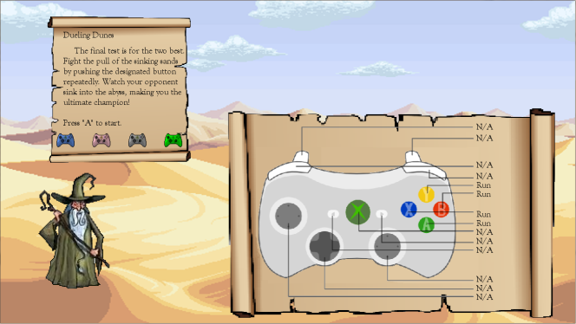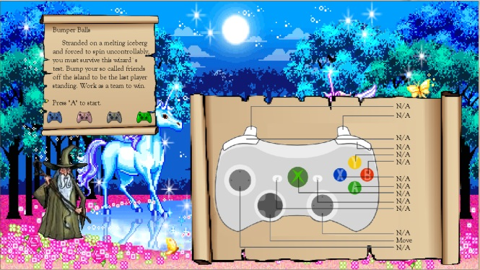

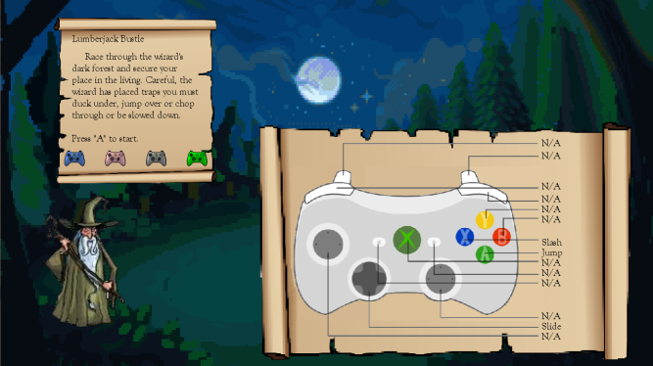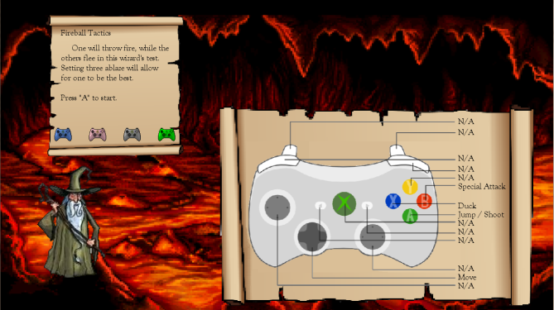

Figure 14‑2 Instruction Screens

## Lumberjack Bustle

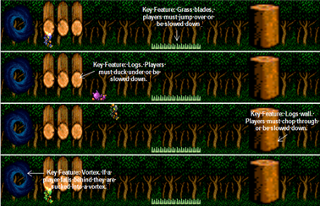

Figure 14‑3 Lumberjack Bustle Game Map

The theme for the mini game Lumberjack Bustle is a dark forest. The screen is divided into four lanes and the players move horizontally across them, until they reach the finish line. Lumberjack Bustle features five main components: Vortex, if the players fall behind they are sucked into the vortex; Logs, players must duck under these logs; Grass blades, players must jump over the blades; Log walls, players must chop through these walls; The finish line, a black and white checkered line that indicates the end of the race.

## Bumper Balls

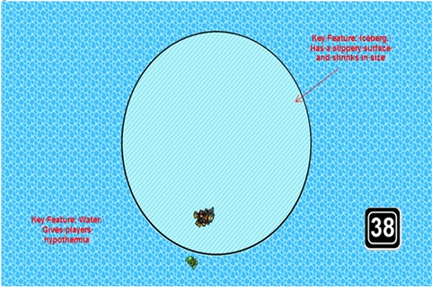

Figure 14‑4 Bumper Balls Game Map

The theme for the mini game Bumper Balls is water. The players are trapped on the game’s key component, an iceberg that reduces in size as the game progresses. An iceberg is also slippery; having a lower coefficient of friction, so that when players run into each other the transfer of momentum is more evident and dangerous. The iceberg is surrounded by water, if players fall in the water they die of hypothermia.

## Fireball Tactics

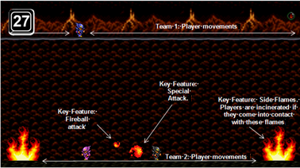

Figure 14‑5 Fireball Tactics Game Map

The theme for the mini game Fireball tactics is fire, lava and rock. Players on the three man team can move horizontally at the bottom of the screen and jump upwards to avoid fireballs. The player on the one man team moves along the upper walkway throwing fireballs and launching special attacks. Key features in this game map are: The side flames, the fireball attacks and the special fireball attack, where balls of fire roll around the bottom of the screen.

## Dueling Dunes

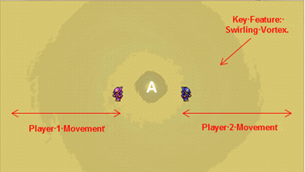

Figure 14‑6 Dueling Dunes Game Map

The theme for the mini game Dueling Dunes map is wind and sand. The map features a swirling vortex that sucks the players into the center of the map. The players move along a horizontal line from the edge of the map to the center of the vortex.

# Mechanics analysis

In Battle Rooms, the player engages in a series of mini games, which each have their own unique characteristics. The common mechanics between each game include a time limit, score system, individual skill and a multiplayer setting. Skill is based on the player’s reaction time as each game has only a small set of actions (at most four). However, each mini game has their own separate set of mechanics which the following sections will discuss.

But before explaining each game, it should be noted that Battle Rooms has two settings: Story Mode and Mini Games. Story Mode arranges the mini games in a pre-defined sequence, where a winner will be determined after the players have played through every mini game. The winner is determined by the player with the most points. Therefore, each game will specifically have a balance mechanism that will allow every player to have equal chances of winning, even if their performance was poor in one of the earlier mini games. However, the scoring is done so that there will always be one winner at the end of the story. Story mode is what ties the games together to create a setting and a backstory.

Essentially, the gameplay is very similar to Mario Party in terms of game mechanics in that this is a game targeted towards a general audience of all ages. Therefore, the game mechanics for each game are not meant to be complex, but easy to pick up. Each mini game is fast paced and is dependent on the player’s skill. Like Mario Party, the scoring is similar to the collection of stars that help determine the winner. However, Battle Rooms only takes points scored at the end of each round into consideration for the winner whereas Mario Party has multiple factors that determine a winner which include amount of gold, random chance, most spaces travelled, etc. Battle Rooms emphasizes only the mini game aspect of Mario Party and not the board game aspect. Story mode replaces the board by adding a narrative to explain what is going on within Battle Rooms.

The Mini Games setting allows players to play any of the mini games. It is for players who simply wish to play a specific mini game for fun or to practice. The winner is determined in the same fashion as Story Mode. The following mini games will be discussed as though the game was played in Story mode.

## Lumberjack Bustle

This is the first game in Story Mode. In Lumberjack Bustle, the game does not suffer from balancing issues as there is no favorable situation; it is a free for all match where all players go through the same obstacle course, move at the same speed, start at the same time and from the same point. Therefore, none of the players have an advantage over another. To be the first to reach the end, the player must at least avoid more obstacles than the other players. The obstacles include chopping through log walls, ducking under a set of three logs and jumping over blades of grass.

If a player collides with an obstacle, they are set to a temporary knockback state that lasts for 0.5 seconds. While in the knockback state, the player is prevented from performing any actions. However, the duration is short enough that it gives the player enough time to react to the next obstacle that comes along. Since the penalty for a player that is knocked back is that they are no longer in first place, they receive a slight advantage by having more time to react to the obstacles. For instance, players that are behind have to duck at a later time compared to players currently in the lead. As the game progresses, the frequency and amount of obstacles generated increases, making it harder for players to avoid all of them, especially those in the lead. However, if a player is knocked back too often, they fall into the vortex, eliminating them from the race. It should be noted that obstacles are randomly generated for each game, making each instance of the game unique.

Although the game does not have a timer, it does have a finite length. This incorporates the time based value that each mini game is required to have.

In the score mechanic, first place receives two points, anyone else that completes the race receives one point and any players that are pulled into the vortex receive zero points. There can be ties in any of the categories, such that everyone could have two points, some with one point or zero points

## Bumper Balls

The game after Lumberjack Bustle is Bumper Balls, a two versus two match. The worst and best players from Lumberjack Bustle are paired together as one team and the remaining two players are paired as the other team. This was a balancing decision in that the player in first place now has the greatest chance of losing in this mini game and the player in last place has the greatest chance of winning. This is under the assumption that a player’s skill is based on how they scored in the previous mini game. If there are no best and worst players, teams are randomly put together.

Certain physics mechanics are incorporated in this game. In Bumper Balls, teams must knock the other team off the platform. When a player bumps another player, both players gain each other’s velocity and direction and combine it with their own velocity and direction, simulating the effect of when momentum is transferred.

The game has a 60 second time limit and as time progresses, the platform shrinks. With a smaller platform, it becomes easier to knock a player off, but at the same time makes it harder to stay on. Additionally, the friction coefficient of the platform simulates the experience of moving on ice, so stopping and initial acceleration requires more time.

Scoring is done as follows. The team with the most players left on the platform receives one point. This helps balance the game as the person who’s first does not get a significant lead over the others

## Fireball Tactics

Fireball Tactics follows after Bumper Balls. The game is one versus three, where the player with the lowest score accumulated at this point is against the other three. The player currently in last place is on top, shooting fireballs at the other players. The other three players are on the bottom, avoiding the fireballs that are being launched at them.

Mechanics in this game involve more physics, as the players can jump around to avoid being hit by a fireball. Fireballs also include their own bounce to add an extra dynamic to shooting. The shooter also has another attack, which sends a larger fireball that rolls on the ground from the left side of the screen all the way to the right. The players avoiding the fireballs are also confined in a specific area as firewalls block the left and right side of the screen. If one of the three players touches anything that is on fire (fireball and firewall), they are defeated in Fireball Tactics.

The game favors the player on top in that by winning this game, they have a chance to get closer to first place. However, during early development, it was too easy for the player on top to win. Balancing mechanics that were introduced to the game include a fireball meter, a reduction in the fireball velocity and an increased duration between each fireball shot. The fireball meter indicates how many fireballs the players have left to shoot. When the player launches a bouncing fireball, it consumes one charge of the fireball meter. If the player sends the large rolling fireball, it consumes three charges. Therefore, the fireball meter prevents the player from recklessly shooting fireballs. When a player shoots any f the fireballs, the fireball meter greys out a bit to indicate to the user that they are unable to shoot.

## Dueling Dunes

The last game in Story Mode is Dueling Dunes, a match between first and second place, which is based on the accumulation of points up until this point. This will determine the winner in Story Mode.

Dueling Dunes is a button masher, where to escape the vortex, players must bash the button that is displayed on the screen. The buttons that appear are either A, B, X or Y. Although there is no time limit, the game will not last that long as the game is stamina intensive. The amount of button presses required to escape the pull of the vortex is X presses per second (need Patrick to give a specific estimate). The pull from the vortex is high enough that If the player does not continuously press the specified button, they will continue to get pulled in.

Just like in Lumberjack Bustle, there is no favorable position as both players initially start from the same distance away from the vortex. It is up to the players individual reaction time and button mashing ability to be determined as the victor.

With respect to the score, any of these players can win. The winner receives four points. If both players lose at the same time, they both receive zero points.

## Score

The following tables are the possible score tallies after each mini game in story mode. Note that this is with respect to one player, so this does not include all possible permutations. At the very least this, there is four times this amount.

|  |  |  |  |  |  |  |  |  |  |  |  |  |  |  |  |  |  |  |  |  |  |  |  |  |  |  |  |  |
| --- | --- | --- | --- | --- | --- | --- | --- | --- | --- | --- | --- | --- | --- | --- | --- | --- | --- | --- | --- | --- | --- | --- | --- | --- | --- | --- | --- | --- |
| **LumberJack Bustle** | | | | |  | **Fireball Tactics** | | | | |  |  |  |  |  |  |  |  |  |  |  |  |  |  | | | | |
| **Scenario** | **Player 1** | **Player 2** | **Player 3** | **Player 4** |  | **Scenario** | **P1** | **P1** | **P3** | **P4** |  |  |  |  |  |  |  |  |  |  |  |  |  |  |  |  |  |  |
| **1** | 0 | 0 | 0 | 0 |  | 1 | 2 | 2 | 1 | 0 | bottom wins |  |  |  |  |  |  |  |  |  |  |  |  |  |  |  |  |  |
| **2** | 2 | 0 | 0 | 0 |  | 1 | 0 | 2 | 2 | bottom wins |  |  |  |  |  |  |  |  |  |  |  |  |  |  |  |  |  |
| **3** | 2 | 2 | 0 | 0 |  | 2 | 2 | 2 | 1 | bottom wins |  |  |  |  |  |  |  |  |  |  |  |  |  |  |  |  |  |
| **4** | 2 | 2 | 2 | 0 |  | 1 | 1 | 2 | 0 | top wins |  |  |  |  |  |  |  |  |  |  |  |  |  |  |  |  |  |
| **5** | 2 | 2 | 2 | 2 |  | 2 | 0 | 1 | 1 | top wins |  |  |  |  |  |  |  |  |  |  |  |  |  |  |  |  |  |
| **6** | 2 | 1 | 0 | 0 |  | 1 | 1 | 1 | 3 | top wins |  |  |  |  |  |  |  |  |  |  |  |  |  |  |  |  |  |
| **7** | 2 | 1 | 1 | 0 |  | 2 | 4 | 2 | 1 | 0 |  |  |  |  |  |  |  |  |  |  |  |  |  |  |  |  |  |  |
| **8** | 2 | 1 | 1 | 1 |  | 3 | 0 | 2 | 2 |  |  |  |  |  |  |  |  |  |  |  |  |  |  |  |  |  |  |
|  |  |  |  |  |  | 4 | 3 | 2 | 1 |  |  |  |  |  |  |  |  |  |  |  |  |  |  |  |  |  |  |
| **Bumper Balls** | | | | |  | 3 | 1 | 0 | 2 |  |  |  |  |  |  |  |  |  |  |  |  |  |  |  |  |  |  |
| **Scenario** | **Player 1** | **Player 2** | **Player 3** | **Player 4** |  | 2 | 2 | 1 | 1 |  |  |  |  |  |  |  |  |  |  |  |  |  |  |  |  |  |  |
| **1** | 1 | 1 | 0 | 0 | team 1 wins | 3 | 2 | 1 | 3 |  |  |  |  |  |  |  |  |  |  |  |  |  |  |  |  |  |  |
| 0 | 0 | 1 | 1 | team 2 wins | 3 | 4 | 3 | 2 | 0 |  |  |  |  |  |  |  |  |  |  |  |  |  |  |  |  |  |  |
| 1 | 1 | 1 | 1 | both win | 3 | 4 | 0 | 2 |  |  |  |  |  |  |  |  |  |  |  |  |  |  |  |  |  |  |
| **2** | 3 | 1 | 0 | 0 |  | 4 | 4 | 2 | 1 |  |  |  |  |  |  |  |  |  |  |  |  |  |  |  |  |  |  |
| 2 | 0 | 1 | 1 |  | 3 | 2 | 1 | 2 |  |  |  |  |  |  |  |  |  |  |  |  |  |  |  |  |  |  |
| 3 | 2 | 1 | 1 |  | 2 | 3 | 2 | 1 |  |  |  |  |  |  |  |  |  |  |  |  |  |  |  |  |  |  |
| **3** | 3 | 2 | 1 | 0 |  | 3 | 3 | 1 | 3 |  |  |  |  |  |  |  |  |  |  |  |  |  |  |  |  |  |  |
| 2 | 3 | 0 | 1 |  | 4 | 4 | 3 | 3 | 1 |  |  |  |  |  |  |  |  |  |  |  |  |  |  |  |  |  |  |
| 3 | 3 | 1 | 1 |  | 3 | 4 | 4 | 0 |  |  |  |  |  |  |  |  |  |  |  |  |  |  |  |  |  |  |
| **4** | 3 | 2 | 2 | 1 |  | 4 | 4 | 4 | 1 |  |  |  |  |  |  |  |  |  |  |  |  |  |  |  |  |  |  |
| 2 | 3 | 3 | 0 |  | 3 | 2 | 2 | 3 |  |  |  |  |  |  |  |  |  |  |  |  |  |  |  |  |  |  |
| 3 | 3 | 3 | 1 |  | 2 | 3 | 3 | 2 |  |  |  |  |  |  |  |  |  |  |  |  |  |  |  |  |  |  |
| **5** | 3 | 3 | 2 | 2 |  | 3 | 3 | 3 | 3 |  |  |  |  |  |  |  |  |  |  |  |  |  |  |  |  |  |  |
| 2 | 2 | 3 | 3 |  | 5 | 4 | 4 | 3 | 2 |  |  |  |  |  |  |  |  |  |  |  |  |  |  |  |  |  |  |
| 3 | 3 | 3 | 3 |  | 3 | 2 | 4 | 4 |  |  |  |  |  |  |  |  |  |  |  |  |  |  |  |  |  |  |
| **6** | 3 | 1 | 0 | 1 |  | 4 | 4 | 4 | 3 |  |  |  |  |  |  |  |  |  |  |  |  |  |  |  |  |  |  |
| 2 | 2 | 1 | 0 |  | 3 | 3 | 2 | 4 |  |  |  |  |  |  |  |  |  |  |  |  |  |  |  |  |  |  |
| 3 | 2 | 1 | 1 |  | 4 | 2 | 3 | 3 |  |  |  |  |  |  |  |  |  |  |  |  |  |  |  |  |  |  |
| **7** | 3 | 1 | 1 | 1 |  | 3 | 3 | 3 | 5 |  |  |  |  |  |  |  |  |  |  |  |  |  |  |  |  |  |  |
| 2 | 2 | 2 | 0 |  | 6 | 4 | 2 | 0 | 2 |  |  |  |  |  |  |  |  |  |  |  |  |  |  |  |  |  |  |
| 3 | 2 | 2 | 1 |  | 3 | 3 | 2 | 0 |  |  |  |  |  |  |  |  |  |  |  |  |  |  |  |  |  |  |
| **8** | 3 | 2 | 1 | 1 |  | 4 | 3 | 2 | 1 |  |  |  |  |  |  |  |  |  |  |  |  |  |  |  |  |  |  |
| 2 | 1 | 2 | 2 |  | 3 | 1 | 2 | 1 |  |  |  |  |  |  |  |  |  |  |  |  |  |  |  |  |  |  |
| 3 | 2 | 2 | 2 |  | 2 | 2 | 1 | 2 |  |  |  |  |  |  |  |  |  |  |  |  |  |  |  |  |  |  |
|  |  |  |  |  |  | 3 | 2 | 1 | 3 |  |  |  |  |  |  |  |  |  |  |  |  |  |  |  |  |  |  |
|  |  |  |  |  |  | 7 | 4 | 2 | 2 | 1 |  |  |  |  |  |  |  |  |  |  |  |  |  |  |  |  |  |  |
|  |  |  |  |  |  | 3 | 3 | 3 | 0 |  |  |  |  |  |  |  |  |  |  |  |  |  |  |  |  |  |  |
|  |  |  |  |  |  | 4 | 3 | 3 | 1 |  |  |  |  |  |  |  |  |  |  |  |  |  |  |  |  |  |  |
|  |  |  |  |  |  | 3 | 1 | 1 | 3 |  |  |  |  |  |  |  |  |  |  |  |  |  |  |  |  |  |  |
|  |  |  |  |  |  | 2 | 2 | 2 | 2 |  |  |  |  |  |  |  |  |  |  |  |  |  |  |  |  |  |  |
|  |  |  |  |  |  | 3 | 2 | 2 | 3 |  |  |  |  |  |  |  |  |  |  |  |  |  |  |  |  |  |  |
|  |  |  |  |  |  | 8 | 4 | 3 | 2 | 1 |  |  |  |  |  |  |  |  |  |  |  |  |  |  |  |  |  |  |
|  |  |  |  |  |  | 3 | 1 | 3 | 3 |  |  |  |  |  |  |  |  |  |  |  |  |  |  |  |  |  |  |
|  |  |  |  |  |  | 4 | 3 | 3 | 2 |  |  |  |  |  |  |  |  |  |  |  |  |  |  |  |  |  |  |
|  |  |  |  |  |  | 3 | 2 | 1 | 3 |  |  |  |  |  |  |  |  |  |  |  |  |  |  |  |  |  |  |
|  |  |  |  |  |  | 2 | 3 | 2 | 2 |  |  |  |  |  |  |  |  |  |  |  |  |  |  |  |  |  |  |
|  |  |  |  |  |  | 3 | 2 | 2 | 4 |  |  |  |  |  |  |  |  |  |  |  |  |  |  |  |  |  |  |

Figure 15‑1 List of possible scores in Story Mode

# Schedule & Related Elements

## Meeting Minutes

### Meeting 1 24/09/2012

Meeting to discuss project idea and proposal

**TASK DISCUSSION & DEVISION:**

**CHRIS**

* Log hours
* Set up Git repository
* Set up project code with preliminary structure.
* Proposal Part 4
  + Related Game 3

**KATRINA**

* Log hours
* Set-up Proposal Power point
* Proposal Part 3
  + Related Game 1
  + Related Game 2

**MATT**

* Log hours
* Proposal Part 2
* Supporting Screenshot
* Mechanics
* Reference Art

**PAT**

* Log hours
* Proposal Part 1
  + Box Art
  + Game Title
  + Tag Line
  + Genre
  + Platform
  + Market
  + Setting
  + Plays Like
  + Summary

**DUE DATE:** Wednesday October 3rd 2012 @ Noon.

### Meeting 2 15/10/2012

Division of coding tasks and architecture discussion

**TASK DISCUSSION & DEVISION:**

**PAT** & **CHRIS**

* Log hours
* Lumberjack Bustle Camera
  + Dependency character and world
  + DUE TUESDAY 30th MIDNIGHT
* Lumberjack Bustle World
  + Terrain
    - DUE SUNDAY 28th MIDNIGHT
  + Randomly generated obstacles (hurtles, limbo, blocks)
    - DUE SUNDAY 28th MIDNIGHT
  + Collision Detection (Dependency on Characters)
    - DUE TUESDAY 30th MIDNIGHT
* Aesthetics
  + Music
    - DUE TUESDAY 30th MIDNIGHT

**MATT** & **KATRINA**

* Log hours
* Characters
  + Controls (duck, jump & shoot)
    - DUE SUNDAY 28th MIDNIGHT
  + Move Forward Constant
    - DUE SUNDAY 28th MIDNIGHT
  + Animation
    - DUE SUNDAY 28th MIDNIGHT
  + Sound
    - DUE SUNDAY 28th MIDNIGHT
  + Collision Methods (methods that Chris and Pat can call on when a collision is detected)
    - DUE SUNDAY 28th MIDNIGHT
* Game Flow
  + Instruction Screen For Mini Game(everyone press start to begin)
    - DUE TUESDAY 30thMIDNIGHT

### Meeting 3 29/10/2012

Follow up meeting to discuss the tasks from meeting 2. Everything is on track.

### Meeting 4 12/11/2012

Meeting to split up documentation and coding tasks.

**TASK DISCUSSION & DEVISION:**

**CHRIS**

* Log hours
* Add # of players to framework
* Main Menu
* Story Screens beginning and end
* Lumberjack - display the right number of players.
* Lumberjack - (bug) collision sound that plays after character is dead.

**KATRINA**

* Log hours
* Scoring System
* Instructions - # of players
* Instructions - add sounds for check-in
* Instructions for Fireball Tactics

**MATT**

* Log hours
* Fireball Tactics Game (3 vs 1)

**PAT**

* Log hours
* Bumper Balls Game (2 vs 2)
* Game 1 vs 1.
* Story screens in between games.

**DUE DATE: November 25th 2012 @ Midnight.**

### Meeting 5 25/11/2012

Follow up meeting to discuss the tasks from meeting 4.

Game voice over scoped out.

### Meeting 6 29/11/2012

Final Meeting to prepare for demo, set up xbox and split up documentation

**TASK DISCUSSION & DEVISION:**

**CHRIS**

* Log Hours
* Development Doc - Section 8 Art Direction
* Development Doc - Section 9 UI
* Development Doc - Section 11 Technology Plan
* Development Doc - Section 12 Architecture
* Development Doc - Section 18 Change Log (update with your changes)
* Development Doc Review - Title Page
* Development Doc Review - Section 1
* Development Doc Review - Section 2
* Development Doc Review - Section 4
* Development Doc Review - Section 7

**KATRINA**

* Log hours
* Development Doc - Title Page
* Development Doc - Section 1 Executive Summary
* Development Doc - Section 3 Related Games
* Development Doc - Section 6 Characters
* Development Doc - Section 14 Level Design
* Development Doc - Section 16 Schedule
* Development Doc - Section 17 Budget
* Development Doc - Section 18 Change Log (update with your changes)
* Development Doc Review - Title Page
* Development Doc Review - Section 9
* Development Doc Review - Section 10
* Development Doc Review - Section 13
* Development Doc Review - Section 15
* Development Doc Review - Section 18

**MATT**

* Log hours
* Development Doc - Section 13 Controls
* Development Doc - Section 15 Mechanical Analysis
* Development Doc - Section 18 Change Log (update with your changes)
* Development Doc Review - Title Page
* Development Doc Review - Section 11
* Development Doc Review - Section 12
* Development Doc Review - Section 14
* Development Doc Review - Section 16
* Development Doc Review - Section 17

**PAT**

* Log Hours
* Development Doc - Section 2 Overview
* Development Doc - Section 4 Player Composite
* Development Doc - Section 5 World
* Development Doc - Section 7 Plot Graph
* Development Doc - Section 10 Tags & Dialogue
* Development Doc - Section 18 Change Log (update with your changes)
* Development Doc Review - Title Page
* Development Doc Review - Section 3
* Development Doc Review - Section 5
* Development Doc Review - Section 6
* Development Doc Review - Section 8

**DUE DATE:** Monday December 3rd 2012 @ Noon.

## Schedule

The Gantt chart below describes our development schedule including dependencies, for further breakdown of the tasks below look at section 16.1 Meeting Minutes. Major milestones include: 03/10/2012 initial setup; 30/10/2012 prototype; 28/11/2012 final release and 03/12/2012 final code and document submission.



Figure 16‑1 Gantt Chart Development Schedule

# Budget

This project’s only expenditure consisted of the labor done by its four developers. During the project the developers recorded their activities and durations in a project log. In total this project took **208.48 hours.** At a conservative salary of 20$ an hour this would amount to $**4,169.60** total cost for the project. Below please find this project’s work log, sorted by date.

|  |  |  |  |  |
| --- | --- | --- | --- | --- |
| **Date** | **Artefact Type** | **Artefact Description** | **Cost (Hours)** | **Initials** |
| 24/09/2012 | Meeting | Meeting to discuss project idea and proposal | 1 | CD |
| 24/09/2012 | Meeting | Meeting to discuss project idea and proposal | 1 | KA |
| 24/09/2012 | Meeting | Meeting to discuss project idea and proposal | 1 | MT |
| 24/09/2012 | Meeting | Meeting to discuss project idea and proposal | 1 | PM |
| 27/09/2012 | Code | Create Repository | 0.1 | CD |
| 27/09/2012 | Code | Create Empty XNA Project | 0.1 | CD |
| 27/09/2012 | Documentation | Prepared presentation and game proposal templates. Also created work log. | 1 | KA |
| 01/10/2012 | Documentation | Added sections to proposal document and proposal presentation | 0.25 | PM |
| 02/10/2012 | Documentation | Added sections to proposal document and proposal presentation | 1 | KA |
| 03/10/2012 | Documentation | Added sections to proposal document and proposal presentation | 0.5 | CD |
| 03/10/2012 | Documentation | Added sections to proposal document and proposal presentation | 0.5 | MT |
| 04/10/2012 | Documentation | Reviewed game proposal and presentation slides and submitted | 0.25 | KA |
| 15/10/2012 | Meeting | Division of coding tasks and architecture discussion | 1 | CD |
| 15/10/2012 | Meeting | Division of coding tasks and architecture discussion | 1 | KA |
| 15/10/2012 | Meeting | Division of coding tasks and architecture discussion | 1 | MT |
| 15/10/2012 | Meeting | Division of coding tasks and architecture discussion | 1 | PM |
| 17/10/2012 | Code | Basic framework for how things will be inserted. | 2 | CD |
| 27/10/2012 | Code | Added and worked on mini game LumberJack Bustle. Made changes to game framework removing and adding classes. | 5 | CD |
| 27/10/2012 | Code | Worked on LumberJackBustle character class | 4 | MT |
| 27/10/2012 | Code | Worked on mini game LumberJack Bustle Added content | 0.5 | PM |
| 28/10/2012 | Code | Worked and made fixes on mini game LumberJack Bustle | 2 | CD |
| 28/10/2012 | Code | Worked on LumberJackBustle character class | 4 | MT |
| 28/10/2012 | Code | Worked on mini game LumberJack Bustle (Load Content & Player List) | 0.5 | PM |
| 29/10/2012 | Code | Changed the resolution to be 720p. Worked and made fixes on mini game LumberJack Bustle | 5 | CD |
| 29/10/2012 | Meeting | Meeting to discuss coding and progress presentation. (Lost power and wasn't present for last 15 mins.) | 1.25 | CD |
| 29/10/2012 | Documentation | Created progress presentation outline and prepared for meeting | 1 | KA |
| 29/10/2012 | Meeting | Meeting to discuss coding and progress presentation. | 1.5 | KA |
| 29/10/2012 | Code | Worked on character class. Added content for different coloured knights. | 2 | MT |
| 29/10/2012 | Meeting | Meeting to discuss coding and progress presentation. | 1.5 | MT |
| 29/10/2012 | Code | Worked on mini game LumberJack Bustle (Draw) Added Camera | 2 | PM |
| 29/10/2012 | Meeting | Meeting to discuss coding and progress presentation. | 1.5 | PM |
| 30/10/2012 | Code | Made modifications/emergency fixes to framework. Worked on mini game LumberJack Bustle (collision) | 3 | CD |
| 30/10/2012 | Code | Worked on content for instruction class and started coding | 4 | KA |
| 30/10/2012 | Code | Worked on mini game LumberJack Bustle character class. | 1 | MT |
| 30/10/2012 | Code | Worked on mini game LumberJack Bustle (Made lanes) Started Bumper Balls mini game and created under construction screen. | 4 | PM |
| 31/10/2012 | Code | Worked on Lumberjack Bustle bugs and code (xbox controller logic) | 0.5 | CD |
| 31/10/2012 | Code | Added content for instruction class Created instruction class for LumberJack Bustle and integrated it into main code. Added string table and Localisation Pipeline Created instruction class for bumper balls | 12 | KA |
| 31/10/2012 | Code | Worked on Lumberjack Bustle bugs added sounds | 1 | MT |
| 31/10/2012 | Code | Worked on Lumberjack Bustle bugs and code (added timer, game balancing, animations) Tested game on Xbox | 2 | PM |
| 01/11/2012 | Code | Worked on Lumberjack Bustle (added songs | 0.1 | CD |
| 01/11/2012 | Documentation | Added slides to progress presentation | 1 | CD |
| 01/11/2012 | Documentation | Added slides to progress presentation, reviewed presentationa and submitted | 0.5 | KA |
| 01/11/2012 | Documentation | Added slides to progress presentation | 0.5 | MT |
| 01/11/2012 | Code | Worked on Lumberjack Bustle last minute fixes and animations (black hole) | 2 | PM |
| 01/11/2012 | Documentation | Added slides to progress presentation | 0.25 | PM |
| 12/11/2012 | Meeting | Meeting to split up tasks | 1.67 | CD |
| 12/11/2012 | Meeting | Meeting to split up tasks | 1.67 | KA |
| 12/11/2012 | Meeting | Meeting to split up tasks | 1.67 | MT |
| 12/11/2012 | Code | Bumper Balls + Framework | 2 | PM |
| 12/11/2012 | Meeting | Meeting to split up tasks | 1.67 | PM |
| 13/11/2012 | Code | Bumper Balls | 3 | PM |
| 16/11/2012 | Code | Finish Bumper Balls + test | 2 | PM |
| 23/11/2012 | Documentation | Created game design document template | 1 | KA |
| 23/11/2012 | Code | Fix team stuff in Bumper balls | 1 | PM |
| 24/11/2012 | Documentation | Worked on game design document budget section | 1.5 | KA |
| 24/11/2012 | Code | Work on Duel Mini Game | 3 | PM |
| 25/11/2012 | Code | Worked on menu system and screenshots for preview | 5 | CD |
| 25/11/2012 | Meeting | Meeting to show changes and discuss progress of coding and possible scoping. | 1 | CD |
| 25/11/2012 | Code | Added scoring and made changes to instructions. | 12 | KA |
| 25/11/2012 | Documentation | Updated game design document | 1 | KA |
| 25/11/2012 | Meeting | Prepare for meeting | 0.5 | KA |
| 25/11/2012 | Meeting | Meeting to show changes and discuss progress of coding and possible scoping. | 1 | KA |
| 25/11/2012 | Code | Worked on Fireball Tactics | 8 | MT |
| 25/11/2012 | Meeting | Showed work on Fireball Tactics | 1 | MT |
| 25/11/2012 | Meeting | Meeting to show changes and discuss progress of coding and possible scoping. | 1 | PM |
| 26/11/2012 | Code | Implemented choose menu fully, and main menu (with cursors). Fixed bugs. | 6 | CD |
| 26/11/2012 | Code | Fixed a bug for all mini games where game over would not occur properly | 1 | CD |
| 26/11/2012 | Code | Made changes to scoring and instructions. | 1 | KA |
| 26/11/2012 | Code | Worked on score and instructions for fire tactics. | 2.5 | KA |
| 27/11/2012 | Code | Implemented the story mode framework for Pat | 1 | CD |
| 27/11/2012 | Code | Made teams depending on score for Duel and BB | 2 | PM |
| 28/11/2012 | Code | Worked on scoring and instructions. | 1.5 | KA |
| 28/11/2012 | Code | Added a firewall to FireballTactics and some other finishing touches | 3 | MT |
| 28/11/2012 | Code | Fixing Bugs, Finishing FireBallTactics | 9 | PM |
| 28/11/2012 | Code | Fixing Bugs, Adding Story + Credits | 5 | PM |
| 29/11/2012 | Meeting | Final Meeting to prepare for demo and set up xbox | 3 | CD |
| 29/11/2012 | Meeting | Final Meeting to prepare for demo and setup xbox | 3 | KA |
| 29/11/2012 | Meeting | Final Meeting to prepare for demo and set up xbox | 3 | MT |
| 29/11/2012 | Code | Last minute bug fixes | 1.5 | PM |
| 29/11/2012 | Meeting | Final Meeting to prepare for demo and set up xbox | 3 | PM |
| 01/12/2012 | Documentation | Updated documentation | 12.5 | KA |
| 03/12/2012 | Documentation | Documentation for the game doc and review | 6 | CD |
| 03/12/2012 | Code | Deployment | 1 | CD |
| 03/12/2012 | Documentation | Reviewed Section 10 | 0.5 | KA |
| 03/12/2012 | Documentation | Documentation for the game doc and review | 6 | MT |
| 03/12/2012 | Documentation | Documentation for the game doc and review | 6 | PM |
| 03/12/2012 | Documentation | Updated document and contributed budget. | 3 | KA |
|  |  | **TOTAL** | **208.48** | **h** |

# Change log

|  |  |  |  |
| --- | --- | --- | --- |
| **Date Modified** | **Rev. #** | **Content Modified** | **Modifed by** |
| 11/23/2012 | 0.0 | Document Creation | KA |
| 11/24/2012 | 1.0 | Updated Section 16 | KA |
| 11/25/2012 | 2.0 | Updated Document | KA |
| 12/01/2012 | 3.0 | Added Executive Summary, Related Games, Characters, Level Design and Schedule. | KA |
| 12/01/2012 | 4.0 | Added Script, Dialogue and Tags section 10 | PM |
| 12/01/2012 | 5.0 | Added plot graphs section 7 | PM |
| 12/01/2012 | 6.0 | Added player composites section 4 | PM |
| 12/02/2012 | 7.0 | Added Art Direction and UI sections | CD |
| 12/02/2012 | 8.0 | Added world section 5 | PM |
| 12/02/2012 | 9.0 | Added overview section 2 | PM |
| 12/03/2012 | 10.0 | Added Mechanic Analysis section 15 | MT |
| 12/03/2012 | 11.0 | Added Controls section 13 | MT |
| 12/03/2012 | 12.0 | Reviewed Document Sections and Added Budget | KA |
| 12/03/2012 | 13.0 | Added architecture section 12 | CD |
| 12/03/2012 | 14.0 | Reviewed Document Sections | MT |
| 12/03/2012 | 15.0 | Added Appendix B | CD |
| 12/03/2012 | 16.0 | Changed all mis-spelt minigame to mini game | CD |

# Appendix A References

x

|  |  |
| --- | --- |
| [1] | Wikipedia. (2012, October) Fuzion Frenzy. [Online]. <http://en.wikipedia.org/wiki/Fuzion_Frenzy> |
| [2] | Wikipedia. (2011, December) Fuzion Frenzy 2. [Online]. <http://en.wikipedia.org/wiki/Fuzion_Frenzy_2> |
| [3] | Microsoft. (2007) Fuzion Frenzy 2. [Online]. <http://www.microsoft.com/games/fuzionfrenzy2/> |
| [4] | Wikipedia. (2012, November) Mario Party. [Online]. <http://en.wikipedia.org/wiki/Mario_Party> |
| [5] | Nintendo. (2012, December) Mario Party 9; Official Site. [Online]. <http://marioparty9.nintendo.com/story.html#/story> |
| [6] | Ubisoft. (2012) Raving Rabbids. [Online]. <http://rabbids.uk.ubi.com/rayman-raving-rabbids/index.html> |
| [7] | Wikipedia. (2012, November) Raving Rabbids. [Online]. <http://en.wikipedia.org/wiki/Raving_Rabbids> |
| [8] | Wikipedia. (2012, November) Rayman Raving Rabbids. [Online]. <http://en.wikipedia.org/wiki/Rayman_Raving_Rabbids> |
| [9] | Wikipedia. (2012, November) Sonic Shuffle. [Online]. <http://en.wikipedia.org/wiki/Sonic_Shuffle> |
| [10] | Wikia; Sonic News Network. (2012, December) Sonic Shuffle. [Online]. <http://sonic.wikia.com/wiki/Sonic_Shuffle> |
| [11] | iStockPhoto. (2012) Wizard with a staff. [Online]. <http://www.google.ca/imgres?start=148&um=1&hl=en&tbo=d&biw=1280&bih=675&tbm=isch&tbnid=OkUkQ1kPeAU-DM:&imgrefurl=http://www.istockphoto.com/stock-illustration-8859013-wizard-with-a-staff.php&docid=d0INPe2CLt-4IM&imgurl=http://i.istockimg.com/file_thumbvie> |
| [12] | James Monroe Treakle. (2010, December) wordpress.com. [Online]. <http://thesilvermirror.wordpress.com/2010/12/29/nr-meet-me-on-holodeck-3/> |
| [13] | Fanpop Inc. (2012, December) Fanpop. [Online]. <http://www.fanpop.com/clubs/mario-party-9/images/30196462/title/mp9-wallpaper> |

x

# Appendix B Credit

This is where the credit for multiple assets used in the creation of our game is.

**Character sprites:**

MANY SPRITES GOTTEN FROM THIS SOURCE:

<http://www.dawezy.com/spritesdb.htm> by Stephen Galano:

* Controllers -  <http://www.clker.com/clipart-26653.html> / <http://www.pixeljoint.com/pixelart/55875.htm>
* Scrolls - <http://www.turbosquid.com/3d-models/scroll-paper-books-3ds/353673>
* Wizard - <http://graphicleftovers.com/graphic/cartoon-wizard-staff/>
* Forest Background - <http://www.wayofthepixel.net/index.php?action=profile;area=showposts;u=6993>
* Bumper Ball Background -  
  http://25.media.tumblr.com/tumblr_lyjqj8IbW01r64y1to1_500.gif
* Fireball Tactics Background -  
  http://forums.penny-arcade.com/discussion/138555/lets-play-quest-for-glory-thanks-to-piotyr-for-keeping-this-going/p25
* Dueling Dunes Background -  
  http://clest.deviantart.com/art/Comission-desert-background-287407935 by ~clest
* LumberjackBustle Obstacles -  
  http://spritedatabase.net/file/4019z

Fireball Tactics fireball -  
 http://i.imgur.com/l9xE5.png  
 Bumper Ball, Dueling Dunes sprites  
 http://www.serebiiforums.com/showthread.php?445537-Help-Me-Create-A-Pokemon-Region!

Holodeck -  
 http://thesilvermirror.wordpress.com/2010/12/29/nr-meet-me-on-holodeck-3/

Cursor -

http://finalfantasy.wikia.com/wiki/Cursor (The Final Fantasy Legend I & II)

**Sound Effects:**

* Jump -[http://www.mobilefish.com/services/sound_effects/sound_effects.php?cat=25&page=2&file=&accesscode=#sounds](http://www.mobilefish.com/services/sound_effects/sound_effects.php?cat=25&page=2&file=&accesscode=)
* Slash and Collide - <http://www.freesound.org/people/qubodup/sounds/60009/>
* Slide - <http://www.flashkit.com/soundfx/Mechanical/Swishes/Nice_Swi-NEO_Soun-8395/index.php>

**Music**

* TheMenu - CricketSaysChill - http://www.newgrounds.com/audio/listen/331534  
  (Licensing Terms: http://creativecommons.org/licenses/by-nc-sa/3.0/, http://creativecommons.org/licenses/by-nc-sa/3.0/legalcode)

**Fonts**

* Emulogic - http://www.fontspace.com/freaky-fonts/emulogic by Freaky Fonts